Sep 28 2017

Thu

Sep 24 2017

Sun

The 20th Asia Masters Athletics Championships

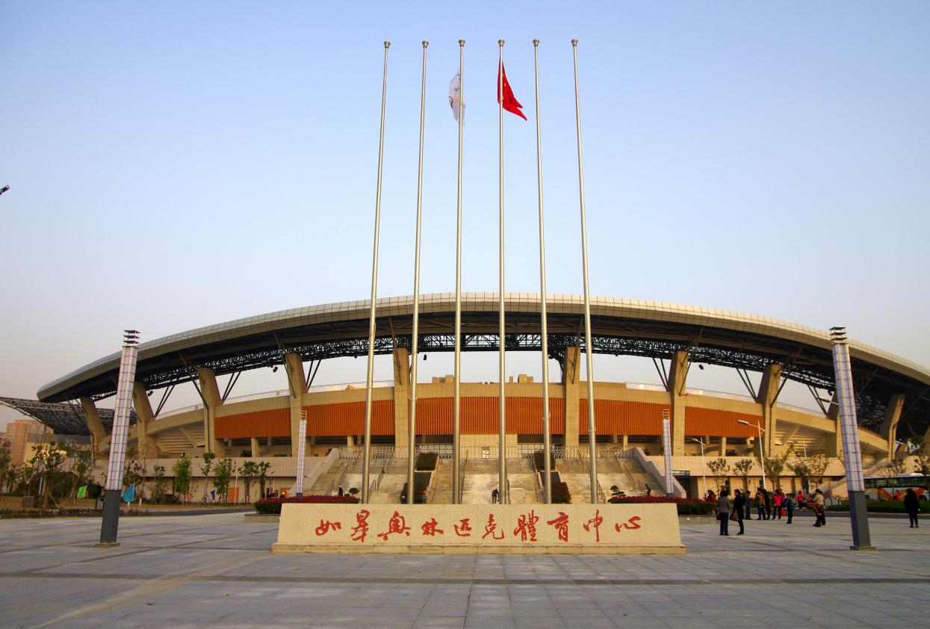

Rugao Olympic Sports Center

TECHNICAL HANDBOOK
Host

Asia Masters Athletics Association

The 20th AMAC Executive Committee
Co-Hosts

Chinese Athletics Association

Jiangsu Sports Bureau

Jiangsu Rugao People's Government
Auspices

RULES & REGULATIONS AND ENTRY INFORMATION

1. ORGANIZATION

Host: CHINA

The 20th AMAC Executive Committee

Co-Hosts: Chinese Athletics Association

Jiangsu Sports Bureau

Jiangsu Rugao People's Government
With the cooperation of ASIA MASTERS ATHLETICS

2. DATE:
Sunday, September 24, 2017 through Thursday, September 28, 2017

3. SCHEDULE
Sunday 24 Sept | Day 1 | 08:00 | Competitions start
 |  | 17:30 | Opening Ceremony
 |  | 19:30 | Welcome Reception
Monday 25 Sept | Day 2 | 08:00 | Competitions start
Tuesday 26 Sept | Day 3 | 08:00 | Competitions start
Wednesday 2t Sept SSSeSSeSSeptemberSeptember | Day 4 | 08:00 | Competitions start
Thursday 28 Sept | Day 5 | 08:00 | Competitions start
 |  | 17:30 | Closing Ceremony

4. VENUE

Jiangsu Rugao Olympic Sports Center

Address: No. 888 Wanshou South Road, Rugao, Jiangsu

E-mail: rglj2016@sina.com Postal code: 226500

Tel.: 0513-87630880 Fax: 0513-87630880

5. CHECK-IN AND TEAM MANAGERS’ MEETING
5,1 Check-in and collection of chest numbers & Accreditation cards
The check-in formalities for all the participating teams will be handled by the Organizing Committee from 8:00-22:00 on September 22 and 8:00-10:00 on September 23 (Beijing time) at: Jiangsu Rugao Olympic Sports Center.
5.2 Contact information
Jiangsu Rugao Olympic Sports Center
No. 888 Wanshou South Road, Rugao, Jiangsu,
Postal code: 226500.

Tel.: 0513-87630880 Fax: 0513-87630880

E-mail: rglj2016@sina.com ,

5.3 Team Managers’ Meeting
The Organizing Committee will hold the Team Managers’ Meeting at 10:30 on September 23, 2017, in which relevant competition issues will be declared and the participating teams shall finally confirm the lists of competing athletes. Each team shall assign 1 Team Manager and 1 Team Representative to attend this meeting.

6. ENTRY
6.1 Entry requirements
Athletes are required to form teams in the name of Affiliates of the Asia Masters Athletics to enter the competition, with no individual entry accepted. As for age category of athletes, only those male and female athletes who are physically fit and born on or before September 24 of 1982 are accepted to enter the 20th Asia Masters Athletics Championships, with the first day of this competition (September 24, 2017) acting as a standard day. The registration means that all participants must comply with relevant provisions in the Handbook of the Asia Masters Athletics and those specified by the Organizing Committee.

6.2 Entry limit
- Events
Events |  | Age Groups |  | Cut-off time
 |  | Male | Female
Track events | 100m | All | All
 | 200m | All | All
 | 400m | All | All
 | 800m | All | All
 | 1500m | All | All | M/W  35-59  60+ and above | 15 mins  18 mins
 | 5000m M/W | All | All | Men  35-59  60-79  80+ and above  Women  35-49  50-69  70+ and above | 30 mins  40 mins  45 mins  35 mins  40 mins  50 mins
 | 10000m M/W | All | All | Men  35-49  50-69  70-79  80+ and above  Women  35-49  50-69  70-79  80+ and above | 60 mins  65 mins  70 mins  80 smin  65 mins  70 mins  75 mins  85 mins
 | 5000mW  M/W | All | All | Men  35-49  50-69  70-79  80+ and above  Women  35-49  50-69  70-79  80+ and above | 50mins  55mins  60mins  65 mins  55 mins  60 mins  65 mins  70 mins
 | 80mH | M70-80 | W40-60+
 | 100mH | M50-65 | W35
 | 110mH | M35-45
 | 200mH | M80+ | W70+
 | 300mH | M60-75 | W50-65
 | 400mH | M35-55 | W35-45
 | 2000mSC | M60+ | All
 | 3000mSC | M35-55 | －
 | 4×100mR | Age groups | Age groups | *
 | 4×400mR | Age groups | Age groups | *
Jumps | High Jump | All | All
 | Pole Vault | All | All
 | Long Jump | All | All
 | Triple Jump | All | All
Throws | Shot Put | All | All
 | Discus | All | All
 | Hammer | All | All
 | Javelin | All | All

- Each participant can enter maximum of 4 individual events (excluding the relay events)
- Relay teams may mix age groups and compete in the lowest age group. A relay team must consists of 6 members of the same country. A relay athlete competing in the lower age group for 1 relay team remains assigned to the same lower age group for relays.
- Entry of the relay teams and payment of the relay events fee must be submitted for registration during the Team Managers’ Meeting on September 23, 2017.
- Each Affiliate may enter only 1 team in each Relay event.

- Age groups

Class |  | Age | Date of birth
Male | Female
M35 | W35 | 35-39 | Born from September 25, 1977 to  September 24, 1982
M40 | W40 | 40-44 | Born from September 25, 1972 to  September 24, 1977
M45 | W45 | 45-49 | Born from September 25, 1967 to  September 24, 1972
M50 | W50 | 50-54 | Born from September 25, 1962 to  September 24, 1967
M55 | W55 | 55-59 | Born from September 25, 1957 to September 24, 1962
M60 | W60 | 60-64 | Born from September 25, 1952 to September 24, 1957
M65 | W65 | 65-69 | Born from September 25, 1947 to  September 24, 1952
M70 | W70 | 70-74 | Born from September 25, 1942 to September 24, 1947
M75 | W75 | 75-79 | Born from September 25, 1937 to  September 24, 1942
M80 | W80 | 80-84 | Born from September 25, 1932 to  September 24, 1937
M85 | W85 | 85-89 | Born from September 25, 1927 to September 24, 1932
M90 | W90 | 90-94 | Born from September 25, 1922 to  September 24, 1927
M95 | W95 | 95-99 | Born from September 25, 1917 to September 24, 1922
M100+ | W100+ | 100 and above | Born on or before September 24, 1917

6.3 Reporting Time
- For all track events : 30 minutes to call room
10 minutes to competition area
- For all field events : 45 minutes to call room
30 minutes to competition area
- For Pole Vault event: 75 minutes to call room
60 minutes to competition area

7. HEALTH INFORMATION

7.1 Participants are recommended to do medical check up before and prepare against the heat, dehydration and so on in advance.
7.2 The Organizing Committee will provide First-Aid service but will not be responsible for the unpredictable accidents, injuries, sickness, thefts or property damages. The Organizing Committee assumes all the participants' families and concerning people understand this and anything that happens to the participants will be self-responsible.
7.3 Participants are recommended to carry the health insurance certificate in case of accidents.
7.4 The organizer will subscribe to accident insurance for the participants, event officials and volunteers during the event.

8.0 GENERAL INFORMATION

8.1 Use of images and personal information
- Personal information listed in the Entry Form will be used as necessary information for the Championships’ management.
- Name, address, and phone number listed in the Entry Form will be used for administrative circular of Championships.
- Participants need to accept that photographs may be taken in any of the activities at the Championships, and such images are the property of the organization. The organization may publish and otherwise use the images for promotional purposes or for any other purposes without the need to obtain any further consent from participants.
8.2 As for unmentioned matters, the Organizing Committee will publish relevant information on the official website of the 20th Asia Masters Athletics Championships (http://www.AmAc2017.cn). More detailed information can be obtained after logging into this website.
8.3 The Organizing Committee possesses the authority for the interpretation of this regulation.

Competition Rules

9. The competition will be held in accordance with IAAF Rules as modified for masters by World Masters Athletics (WMA) / Asia Masters Athletics (AMA), via their handbook and any special rules specified for this competition by the Organizing Committee
10. Participating athletes are required to wear the chest number clothes, uniformly compiled and distributed by the Organizing Committee.
11. AWARDS : 1st, 2nd and 3rd place winners will be awarded certificates and medals at the podium; 4th to 8th place finishers will be awarded the certificates at the award booth.

12. PROTEST
12.1 Any protest related to the competition shall be made in writing by team manager or coach, with the cash of US$ 100, which will not be paid back in the case of failure.
12.2 Any athletes proved to violate the rules of Asia Masters Athletics Championships will be disqualified from the competition.
12.3 Athletes participating in all the events (indoor and outdoor) will be randomly picked to undergo the doping test during the competition.

13. Participants are not allowed to bring their own equipment except for the poles for pole vault event.
13.1 The poles should be sent to the below address on below dates.
- Rugao Olympic Sports Center, No. 888 Wanshou South Road, Rugao
- To Mr. Wang Guanfei (Tel.: 0513-87630880)
- before September 23, 2017.
13.2 For the collection of poles after the event: please make arrangements with the official .

Registration
14. Entry Forms
14.1 Entry Forms shall be submitted through the Affiliates of Asia Masters Athletics in various Asian countries. If athletes come from any Asian country which is not Affiliated to Asia Masters Athletics, then those entry forms must be reviewed and approved by the Asia Masters Athletics.
14.2 Participants can obtain Entry Forms from the Asia Masters Athletics Affiliates in their respective countries.
14.3 Participants shall send Entry Forms, copies of ID cards or passports (indicating the athlete's date of birth), fitness certificates and Entry Fee to the Asia Masters Athletics Affiliates in their countries .

15. Online Registration procedures for the Asia Masters Athletics Affiliates in various countries
15.1 Log into the official website of "The 20th Asia Masters Athletics Championships (http://www.AmAc2017.cn)" and "Online registration for the 20th Asia Masters Athletics Championships" to download descriptions on the online registration for "The 20th Asia Masters Athletics Championships".
15.2 Fill in the Online Registration and Entry Form.
15.3 Use a credit card to pay the fees when submitting the Entry Form upon the completion of registration. (deadline for submission of Entry Forms: June 23, 2017)
15.4 The Asia Masters Athletics Affiliates in the athletes' countries must send the summary sheets of participating athletes (computer typescripts and copies) and all the materials concerning the registration of athletes (which are affixed with seals of such associations) through mails or express deliveries to the Organizing Committee of Asia Masters Athletics Championships before June 23, 2017.
15.5 The Asia Masters Athletics and the Organizing Committee of 20th Asia Masters Athletics Championships are entitled to refuse any applications for insufficient materials concerning the championships participation and for failure of full payment. Once the application process is finished, relevant information will be unalterable or irretrievable. Once the fees related to the championships are paid, they will not be paid back in the case of withdrawal and cancellation or delay of the championships due to weather or other reasons.

16. Manual Registration procedures for the Asia Masters Athletics Affiliates in various countries
16.1 For the Asia Masters Athletics Affiliates which have no accessible to internet facilities or sending big contingents may register their entries manually by filling in the Master Entry List and send to the Organizing Committee together with the original entry forms and all the materials concerning the registration of athletes (which are affixed with seals of such associations) through mail or express deliveries to the Organizing Committee of 20th Asia Masters Athletics Championships before June 23, 2017.

Registration fees
17. Entry Fees
Each participant shall pay the following fees:
17.1 AMA Fee: US$10 (fee paid to the Asia Masters Athletics)
17.2 Management Fee: US$5 (fee paid to the Organizing Committee)
17.3 1st Event Fee: US$10
2nd to 4th event Fee: US$5 (per event)

Event Entry Fee to be paid by participants:
One Event (Total) = US$25
Two Events (Total) = US$30
Three Events (Total) = US$35
Four Events (Total) = US$40
17.4 Relay Event: 1 Team US$20
17.5 International Welcome Reception Fee: US$25 per person - optional
(including the team managers, event officials, etc.)
17.6 Additional Entry Fee incurred by the delay in registration: US$15 per person. Deadline for delay in registration: July 8, 2017.

17.7 International Welcome Reception
Date & Time: | To start at 19:30 on September 24, 2017
Place: | To be informed later
Host: | The Organizing Committee
Purpose: | Meeting with other Asian Athletes
Fee: | US$25 per person
18. General
The Organizing Committee will establish the logistics and reception center and recommend different levels of inns (hotels) and restaurants. Each team shall contact the reception center on issues of accommodation, transportation and others at its own discretion and expense. The Organizing Committee will publish detailed contact information in the official website of the 20th Asia Masters Athletics Championships (http://www.AmAc2017.cn).

Annexure 1: Technical Specifications for Hurdles

Gender | Category | Event | Class | Height | Number of Hurdles | Distance to First Hurdle | Distance Between Hurdles | Distance to Finish | Notes
Male | Sprint | 110mH | M35-M45 | 0.991m | 10 | 13.72m | 9.14m | 14.02m
 |  | 100mH | M50-M55 | 0.914m | 10 | 13.00m | 8.50m | 10.50m
 |  | 100mH | M60-M65 | 0.840m | 10 | 12.00m | 8.00m | 16.00m
 |  | 80mH | M70-M75 | 0.762m | 8 | 12.00m | 7.00m | 19.00m
 |  | 80mH | M80+ | 0.686m | 8 | 12.00m | 7.00m | 19.00m
 | Middle | 400mH | M35-M45 | 0.914m | 10 | 45.00m | 35.00m | 40.00m
 |  | 400mH | M50-M55 | 0.840m | 10 | 45.00m | 35.00m | 40.00m
 |  | 300mH | M60-M65 | 0.762m | 7 | 50.00m | 35.00m | 40.00m
 |  | 300mH | M70-M75 | 0.686m | 7 | 50.00m | 35.00m | 40.00m | Hurdle height: 0.7m
 |  | 200mH | M80+ | 0.686m | 5 | 20.00m | 35.00m | 40.00m | Hurdle height: 0.7m
Female | Sprint | 100mH | W35 | 0.840m | 10 | 13.00m | 8.50m | 10.50m
 |  | 80mH | W40-W45 | 0.762m | 8 | 12.00m | 8.00m | 12.00m
 |  | 80mH | W50-W55 | 0.762m | 8 | 12.00m | 7.00m | 19.00m
 |  | 80mH | W60+ | 0.686m | 8 | 12.00m | 7.00m | 19.00m | Hurdle height: 0.7m
 | Middle | 400mH | W35-W45 | 0.762m | 10 | 45.00m | 35.00m | 40.00m
 |  | 300mH | W50-W55 | 0.762m | 7 | 50.00m | 35.00m | 40.00m
 |  | 300mH | W60-W65 | 0.686m | 7 | 50.00m | 35.00m | 40.00m | Hurdle height: 0.7m
 |  | 200mH | W70+ | 0.686m | 5 | 20.00m | 35.00m | 40.00m | Hurdle height: 0.7m

Annexure 2: Technical Specifications for Steeplechase Heights

Gender | Events | Class | Hurdle height | Number of Obstacles | Number of Water Pits
Male | 3000mSC | M35-M55 | 0.914m | 28 | 7
 | 2000mSC | M60+ | 0.762m | 18 | 5
Female | 2000mSC | W35+ | 0.762m | 18 | 5

Annexure 3: Technical Specifications for Throwing Implements

Gender | Class | Shot/ | Hammer | Discus | Javelin
Male | M35-M45 | 7.26kg | 7.26kg | 2.0kg | 800g
 | M50-M55 | 6.0kg | 6.0kg | 1.5kg | 700g
 | M60-M65 | 5.0kg | 5.0kg | 1.0kg | 600g
 | M70-M75 | 4.0kg | 4.0kg | 1.0kg | 500g
 | M80+ | 3.0kg | 3.0kg | 1.0kg | 400g
Female | W35-W45 | 4.0kg | 4.0kg | 1.0kg | 600g
 | W50-W55 | 3.0kg | 3.0kg | 1.0kg | 500g
 | W60-W70 | 3.0kg | 3.0kg | 1.0kg | 500g
 | W75+ | 2.0kg | 2.0kg | 0.75kg | 400g

Annexure 4: Proposed Heights for  High Jump | Annexure 5: Proposed Heights for  Pole Vault
Gender Class Height  Practice Start Progressions  Male M35 1.35m 1.40m 5cm  M40-M45 1.25m 1.30m  M50 1.20m 1.25m  M55 1.10m 1.15m  M60-M65 1.00m 1.05m  M70 0.95m 1.00m  M75-M80 0.85m 0.90m  M85+ 0.75m 0.80m  Female W35 1.10m 1.15m 3cm  W40 0.95m 1.00m  W45-W50 0.85m 0.90m  W55-W60 0.80m 0.85m  W65-W75 0.70m 0.72m  W80+ 0.60m 0.62m | Gender Class Height  Practice Start Progressions  Male M35 2.60m 2.70m 10cm  M40 2.40m 2.50m  M45 2.30m 2.40m  M50 2.10m 2.20m  M55 1.90m 2.00m  M60 1.70m 1.80m  M65 1.60m 1.70m  M70 1.50m 1.60m  M75 1.40m 1.50m 5cm  M80+ 1.40m 1.50m  Female W35 1.60m 1.70m 10cm  W40 1.50m 1.60m  W45-W50 1.40m 1.50m  W55-W60 1.30m 1.40m  W65+ 1.20m 1.30m 5cm
Annexure 6

Schedule of Events
Events | 9/24 Sun |  | 9/25 Mon |  | 9/26 Tue |  | 9/27 Wed |  | 9/28 Thu
 | Male | Female | Male | Female | Male | Female | Male | Female | Male | Female
100m |  |  |  |  |  |  | All | All
200m |  |  | All | All
400m |  |  |  |  | All | All
800m |  |  | M60-100 | W60-100 |  |  | M35-55 |  |  | W35-55
1500m |  |  |  |  | All | All
5000m |  |  | All |  |  |  |  | All
10000m |  |  |  |  |  | W35-100 |  |  | M35-100
80mH |  |  |  |  | M70-85 | W40-65
100mH |  |  |  |  | M50-65 | W35
110mH |  |  |  |  | M35-45
200mH |  |  |  |  |  |  | M80-100 | W70-100
300mH |  |  |  |  |  |  | M60-75 | W50-65
400mH |  |  |  |  |  |  | M35-55 | W35-45
2000mSC |  |  | M60-100 | W35-100
3000mSC |  |  | M35-55
5000mW | All | All
High Jump |  |  | M70-100 | W60-100 | M35 | W35-55 | M50-65 |  | M40-45
Pole Vault |  |  | M75-100 | All | M60-70 |  | M35-55
Long Jump |  |  | M60-65 | W60-100 | M35-55 | W35-55
 |  |  | M80-100 |  | M70-75
Triple Jump |  |  |  |  | M80-100 | W60-100 | M40-55 | W35-55 | M35
 |  |  |  |  |  |  |  |  | M60-75
Shot Put |  |  | M70-100 | All | M35-65
Discus Throw |  |  |  | All | All
Hammer Throw | M60-100 | All | M35-55
Javelin Throw |  |  |  |  |  |  | M70-100 | All | M35-65
4x100 m Relay |  |  |  |  |  |  |  |  | Age groups | Age groups
4x400 m Relay |  |  |  |  |  |  |  |  | Age groups | Age groups
* The Schedule of Event will be confirmed according to the final situation of registrations and published in the official website of the 20th Asia Masters Athletics Championships in time.
Annexure 7:
Entry Form

No. | Official use only | Name | (Surname/family name) |  | Date of Birth |  |  | Day/Month/Year  / / |  |  | Age on 24 Sept. 2017  years old
 |  |  | (First name)
Nationality |  |  |  |  |  |  |  | Telephone
 |  |  |  |  |  |  |  | E-mail address | @
Address |  |  |  |  |  | (zip: ) |  |  |  | Gender |  | Age groups
 |  |  |  |  |  |  |  |  |  | M/W
Events |  | 1 |  | 2 |  |  | 3 |  |  | 4
Relays |  | 1 |  |  |  |  | 2
Welcome Reception  circle one |  | Participate |  |  |  |  | Absence
I agree that I'm physically fit and already well prepared for the competition on the basis of knowledge I've acquired and my beliefs. I accept the provisions concerning responsibilities for any accidents, injuries, physical damages and property losses related to and occurring in the competition, which are formulated by the Asia Masters Athletics and the Organizing Committee of 20th Asia Masters Athletics Championships.

Participant's name (personal signature): Date:
Fees
AMA Fee | US$ 10 | Dollars
Management Fee | US$ 5 | Dollars
1ST Event fee | US$ 10
2nd – 4th Events  …… Events |  | Dollars
Welcome Reception Fee |  | Dollars
Total |  | Dollars

Notes:
1. 1st event: US$10, 2nd – 4th events : US$5 (per event)
plus AMA Fee US$10 and Management Fee US$5.

2. Welcome reception: US$25 per person.

Fitness and Requirements
Competitors need to be medically and physically fit and be able to participate in the Championships. Before the entry, all participants must check the Health Checklist below. If there is an applicable item, participants need to consult with a primary care doctor and deal each item at one's own responsibility. Please carry the health insurance certificate just in case.
HEALTH CHECKLIST:
(A) If there is at least one applicable item in the following 1 to 4, each participant needs to consult with a primary care doctor on whether to compete in the Championships or not. If needed, each participant must have a medical examination and/or heart examination. All participants need to deal each item at one's own responsibility.
□ Have heart disease, including but not limited to the heart infarction, angina, cardiomyopathy, valve disease and irregular heartbeat, or in treatment for heart disease.
□ Have a history of fainting episode.
□ Have a family history of heart attack.
□ Have not done a medical examination over one year.
(B) If there is at least one applicable item in the following 5 to 8 which is a risk factor of heart infarction and angina, each participant needs to consult with a primary care doctor to stabilize its condition before the Championships.
□ High blood pressure
□ High blood sugar
□ High cholesterol and/or natural fat
□ Smoker
Interpretation: "Primary care doctor" shall refer to a doctor who takes care of a participant's health and physical condition.

Memo note

Athletic Field Distribution
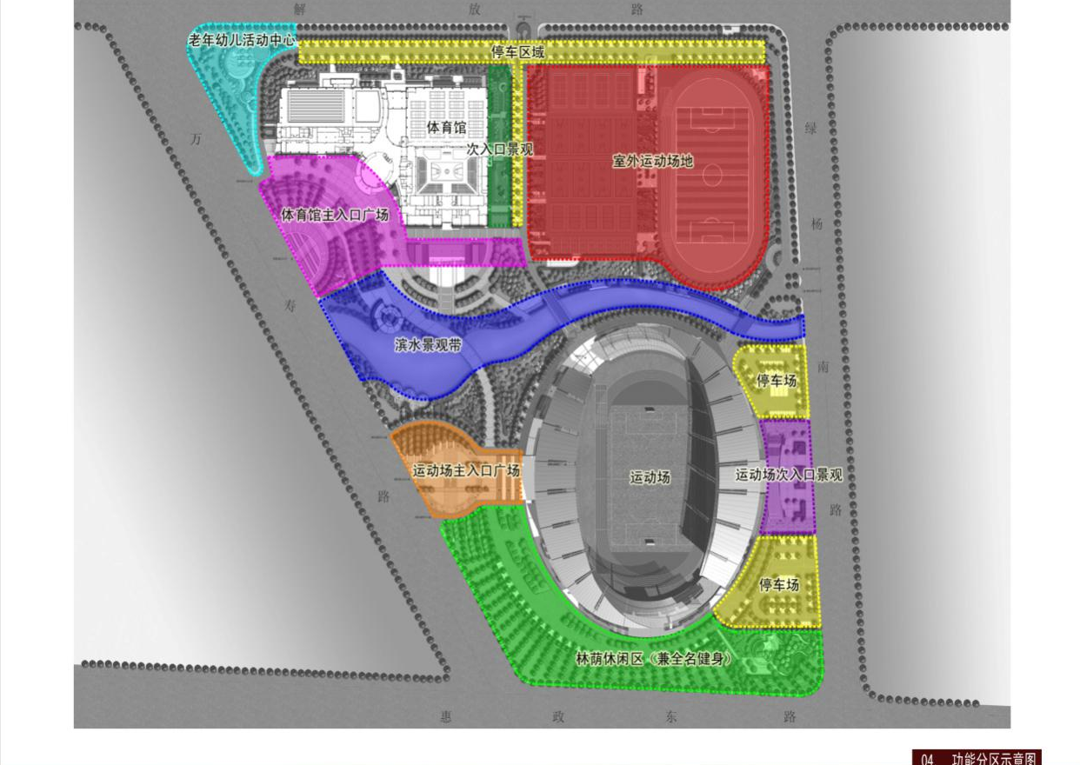
Huizheng East Road
Wanshou Road
Square at the primary entrance of the field
Parking lot
Square at the primary entrance of the gymnasium
Landscape at the secondary entrance

Gymnasium
Entertainment center for the aged people and kids
Parking area
Jiefang Road

04 Sketch Map of Function Division
Landscape at the secondary entrance of the field
Waterfront landscape zone
Lvyang South Road
Boulevard leisure area (also Quanming Fitness)

Parking lot
Athletic field
Outdoor sport field
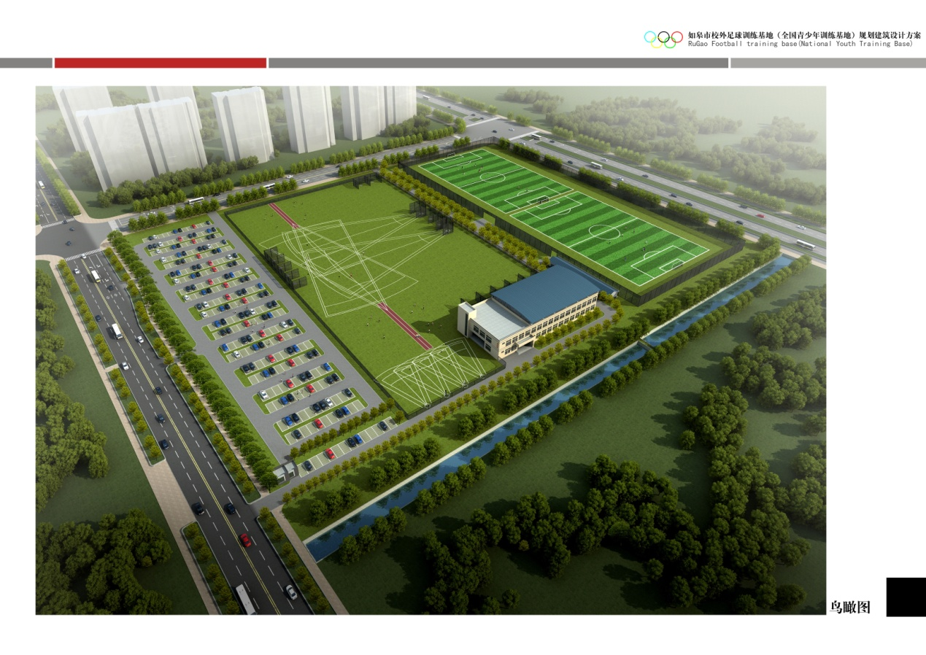
Aerial view

